**HOW TO USE THE EPYQ TOOL**

EpyQ tool is a GUI that allows the user to start the EPC inverter and adjust controller/system parameters. Commands and data are interfaced with inverter controller via CAN/USB. Latest version of EpyQ tool can also be used to update the controller firmware 5 times faster than Oztek firmware update.

NB:

1. Install latest version of EpyQ tool (see SVN folder: ...\t_cprj\00 Project management\10 Customer projects\91 EPC_Power\200 Software\EPyQ Oct 2016)

2. Install PCAN-USB driver (see folder: ...\t_cprj\00 Project management\10 Customer projects\91 EPC_Power\200 Software)

**A. How to update firmware with epyq tool**

See the readme file "readme versions of out file.txt" in the SVN folder: ...\t_cprj\00 Project management\10 Customer projects\91 EPC_Power\200 Software

**B. How to start controller with epyq tool**

1. Open epyq tool and check the communications boxes. It should look as follows:

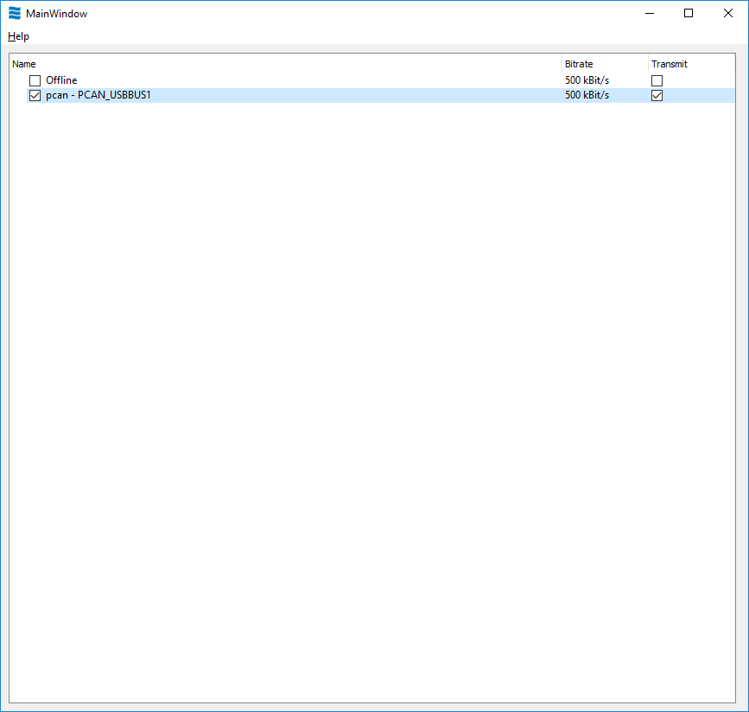

NB: The PC should be connected to the controller in order to be able to see the above options

2. Right-click on the PCAN tool and select ‘load device’. Select ‘distributed generation’. The latest ‘distributed generation’ as of the time of writing this document (Dec 8th 2016) is found in SVN: … \t_cprj\00 Project management\10 Customer projects\91 EPC_Power\200 Software. The file is named ‘DG_Factory_11_30_16’

3. Click both communications boxes of the application and the result should look like this photo:

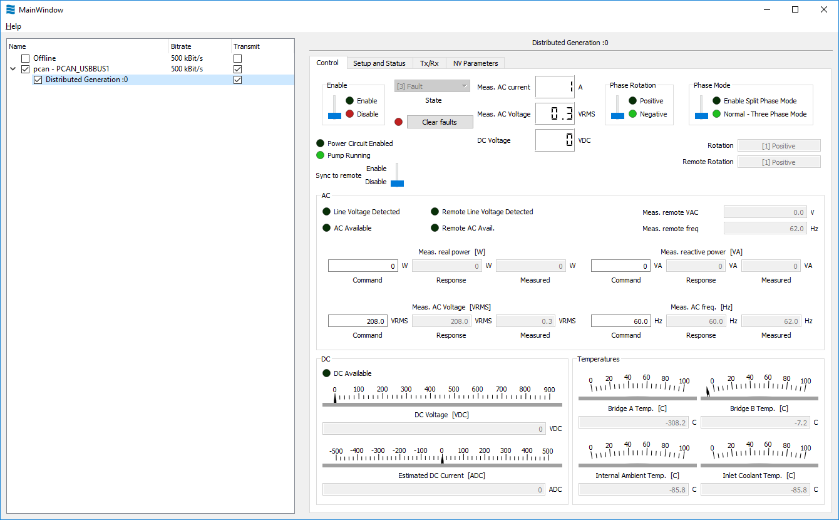

4. By default, the epyq tool sets the active and reactive power references as shown in the highlighted boxes below:

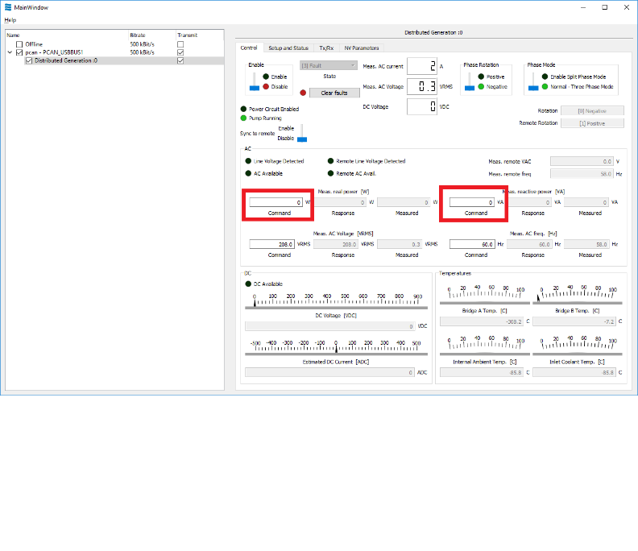

However, you cannot go beyond 800W, which is not quite useful, therefore you need to set the id and iq reference currents instead. To do this, you must update the NV Parameters (see the NV Parameters tab). You can do this manually in the “AfeConfig:UsePcmdAsIcmd” by setting it to “Enable”. Or you can load a preset configuration file called “DG_Defaults_for_new_Epyq_removed_id_iq_offset.json” located in SVN: … \t_cprj\00 Project management\10 Customer projects\91 EPC_Power\200 Software. This configuration file also sets the id and iq offsets to 0, which allows for best calibration of sensors with the scaling factors used in the HIL settings file. Under NV Parameters tab, follow the procedure

1. Click ‘from file’
2. Select the file “DG_Defaults_for_new_Epyq_removed_id_iq_offset.json”
3. Click ‘to inverter’. Settings are now loaded.

NB: always click ‘to inverter’ if you modify a parameter

5. To start the inverter you must always do the following:

a. Under ‘Setup and Status’ tab, in the ‘HW Enable’ panel, select ‘Invert’.

b. Under ‘Control’ tab, select ‘Clear faults’, and then click ‘Enable’ to start the inverter.

There are two voltage sensor configurations that will affect other details of startup process: (i) Voltage sensor located between MCB and GCB (ii) Voltage sensor located between MCB and the grid.

Case (i): Voltage sensor located between MCB and GCB

1. If you want the inverter to operate in standalone mode only, leave all contactors on auto control and simply start as shown in above. It is a good idea to always select the ‘Phase rotation’ as ‘positive’ (this is important in UPS mode).
2. If you want the inverter to operate in grid tied mode only, under ‘Control’ tab, manually close the MX2 contactor. Then leave ‘Use Vsense as remote’ on ‘Use Local Sense’ (under Setup and Status panel). Disable ‘UPS Mode’. In ‘Control’ tab, put the ‘Sync to remote’ as ‘Enable’. Then start the converter as explained in steps 5(a) and 5(b).
3. UPS mode means that the inverter will operate as standalone is there is no utility and then switch to grid-tied mode when the utility becomes available. If you want the inverter to operate in UPS mode, select ‘Enable’ in the ‘UPS Mode’ panel under the ‘Setup and Status’ tab. Then start the inverter as in standalone (step a). Please select ‘positive phase rotation’ and select ‘sync to remote’. When you start the inverter, it runs in standalone. When you manually close MX2, it switches to grid-tied mode.

Case (ii): Voltage sensor located between MCB and the grid

1. If you want the inverter to operate in standalone mode only, follow same steps as in case (i).
2. If you want the inverter to operate in grid tied mode only, follow same steps as in case(i)b, except that you select ‘Use Remote sense’ in the ‘Use Vsense as remote’ parameter under the Setup and Status tab.
3. UPS mode, if selected, will always go to grid tied (since the voltage measurement is permanently seeing a voltage on the grid side)